Chap 8 Programming Exercises Tyler Paulley

Exercise 7: GCD

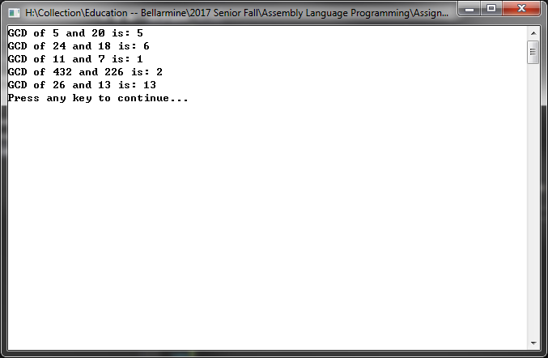

Exercise 8: Count Matches

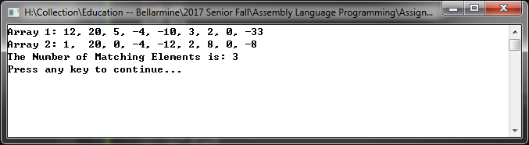

Exercise 9: Count Near Matches

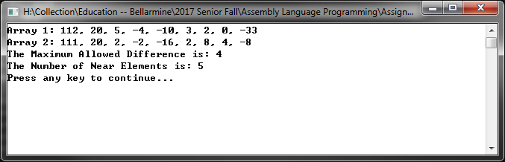

Exercise 10: Show Params

